**1 System Information**

**MySQL version Information:**

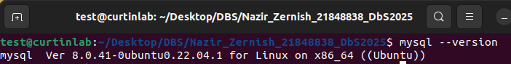

**Operating system Information:**

Version of ubuntu

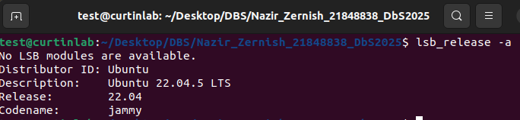

**Python Version:**

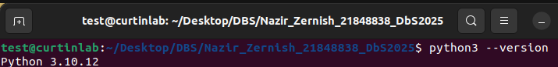

**2 Logging into MySQL**

* Write the command **sudo mysql -u root** to login to MySQL,
* You will then be prompted for password. Enter it and once logged in you will have access to MySQL

**3 Executing MySQL Scripts**

**Testing:** Each script includes test cases (e.g., trigger validation).

**Run the following scripts in given order-** each script executes the tasks specified**:**

1. **create_tables.sql**

**(Implementation)**

This script creates all database tables with proper constraints, implementing the relational schema from Part 1. It defines:

* **Tables**: Championship, Team, GrandPrix, Driver, DriverResultsGP, and TeamStandings.

1. **insert_values.sql**

**(Loading Sample Data)**  
Populates tables with sample records from sources to demonstrate functionality

1. **level1_queries.sql**

**(Level 1 Queries)**  
Demonstrates basic SQL operations

1. **level2_queries.sql**

**(Level 2 Queries)**  
Uses advanced SQL features and gives query results

1. **advanced_features.sql**

**(Advanced Functionality)**  
Adds automation

**4 Python Connection**

Exit MySQL

* 1. **First install required packages**

sudo apt install python3-pip

pip3 install mysql-connector-python

* 1. **Run the script**

python3 f1_database_operations.py

**What does the script do:**

This script connects to MySQL database using secure credentials (via the dedicated f1_admin user), executes all five Level 1 queries and demonstrates insert, delete, update, etc operations by inserting a new race result, updating driver points, and deleting a record before closing the connection.